**Upload Image to IBM Container Registry**

|  |  |
| --- | --- |
| Date | 13 Nov 2022 |
| Team ID | PNT2022TMID23716 |
| Project Name | Smart Fashion Recommender Application |

1.Install the OS and insert the images by using the OS in Docker

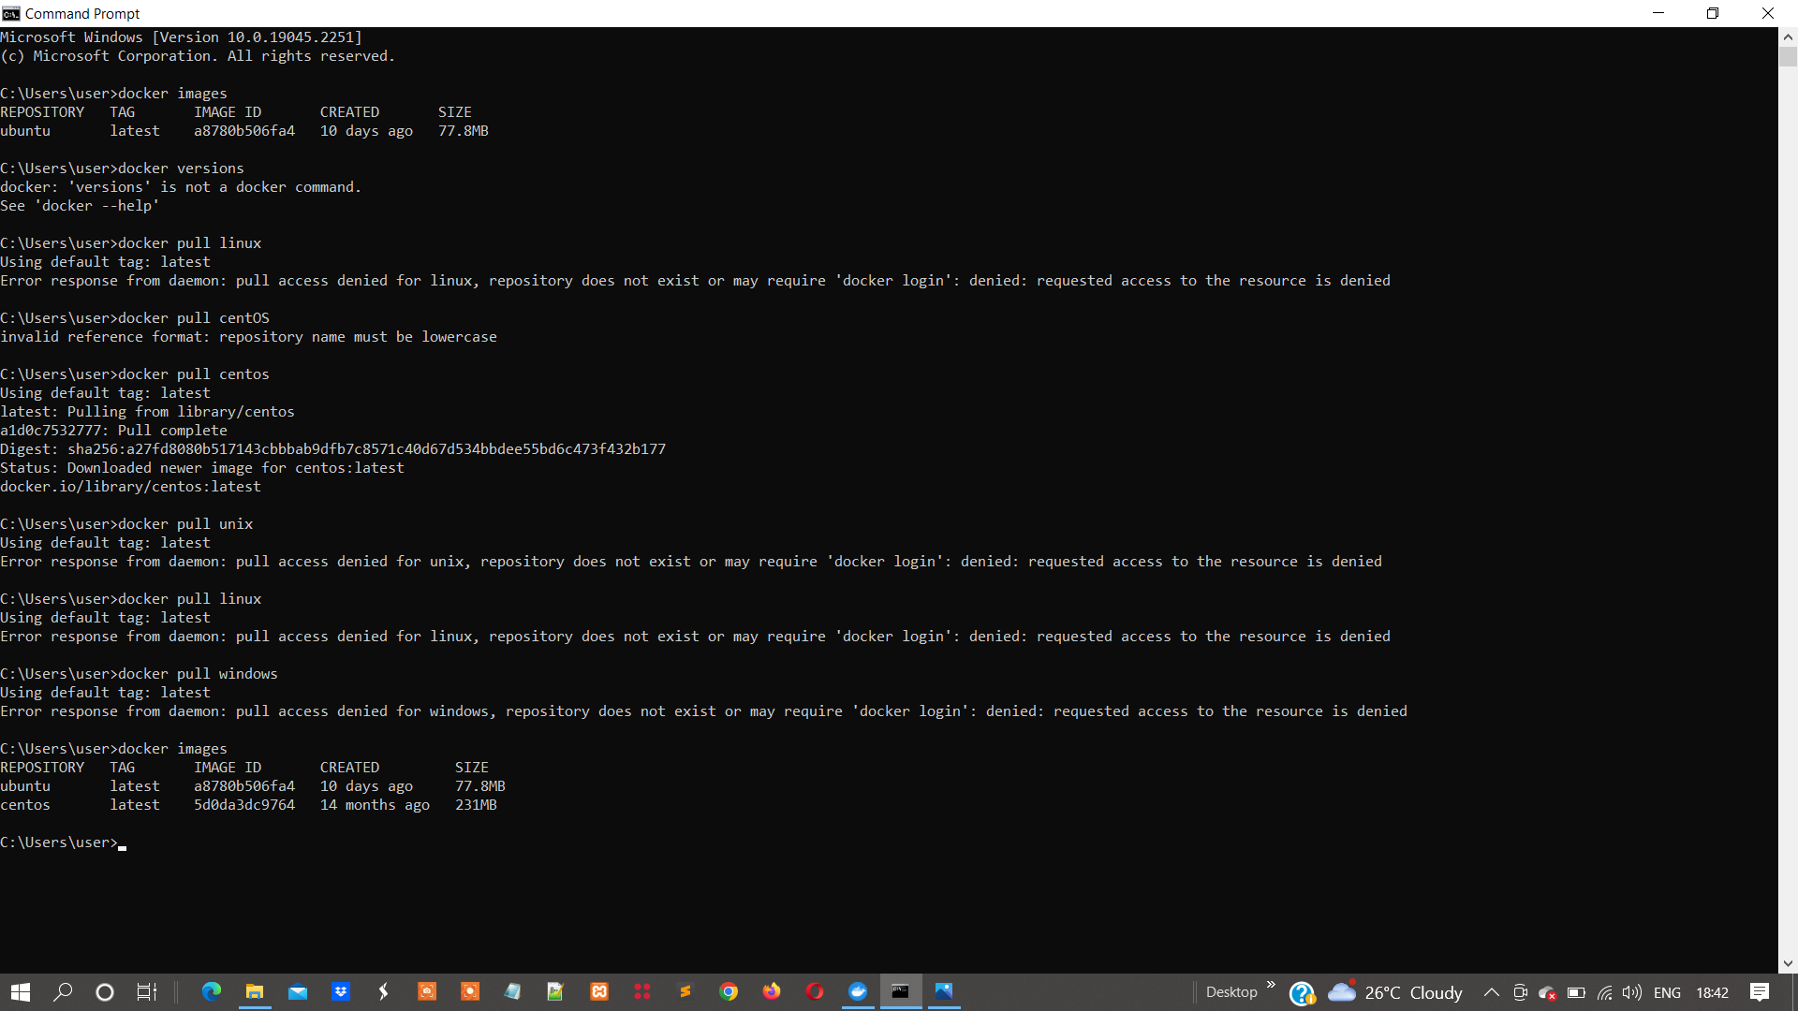2.Install the OS through the command prompt

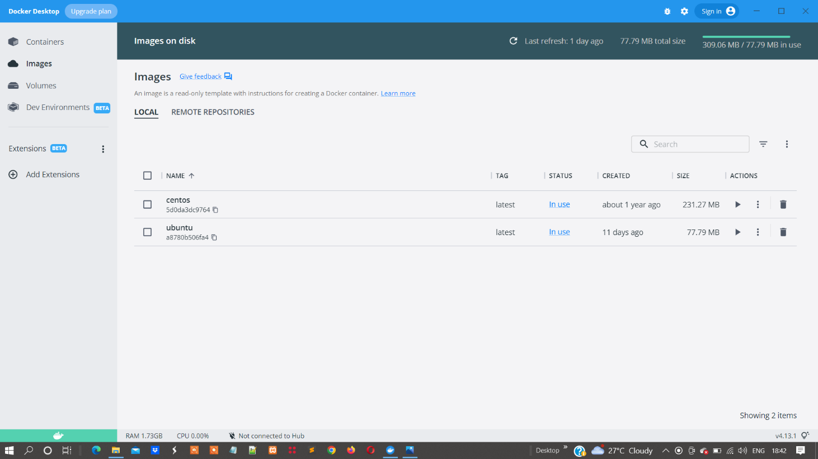1.Installed images of OS

2.Images will run through the containers

